**Music-related APIs**

**Research paper by Dimitar Petrov**

*Abstract:*

The focus of this paper is about APIs that are related to music and streaming services such as Spotify and Soundcloud. With the popularization of music being provided to us online, many web applications have been created to either re-apply the functions that big music streaming services offer, or offer other interesting ideas made by using the data provided.

**Questions**

1. What are the most commonly used music-based APIs?
2. What can one make with an API like this?
3. Do startup-made APIs compete with the ones from streaming corporations?
4. **Introduction**

Music is all around us these days. What used to be a big industry a decade ago, has exploded into a monolith of an industry, making this medium more accessible to us than it has ever been. And with its quickly rising popularity in the online world came the interests of developers. It was not an uncommon idea for both beginners and experienced coders alike to use the data of these now enormous databases of musical records for their own projects, and due to the many requests of programmers have emerged several APIs that assist with the fetching of data like this. In this paper, we will look at two of the largest music distributor’s official APIs – Spotify and Soundcloud, along with a few third-party ones.

1. **Commonly used API**
   1. **Spotify API**

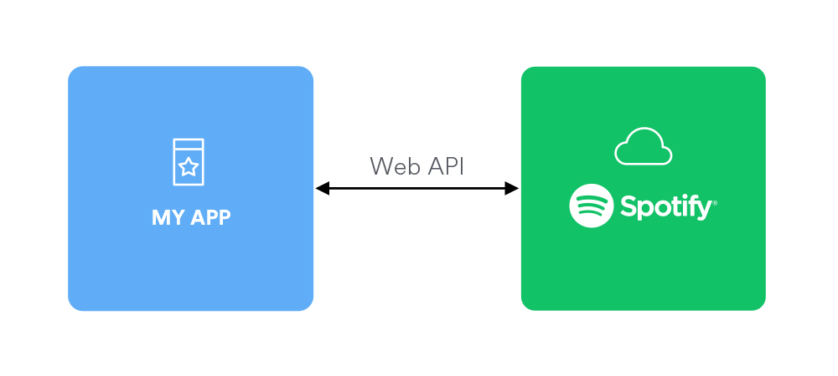

It would be a fair idea to start this research paper with the biggest musical streaming service available to us at the moment – and that of course is Spotify. As mentioned in the introduction, this provider has their own public API free to use by anyone. All that the developer needs to do is create a Spotify account and declare their domain in the Spotify Developers page (<https://developer.spotify.com/documentation/web-api/>).

It follows basic CRUD principles, meaning it offers a function for creation, reading, updating, and deleting content. This opens up many options for a developer to code into their project – from a function that displays a logged in Spotify account’s currently playing song, to a playlist manager. For obvious reasons, the CRUD functions extend to a logged in Spotify content, such as personal data such as Liked Songs, Playlists and Playlist content, and do not include any functions towards their artist and project database.

The Spotify API turned out to be incredibly comfortable for use. It is extensive, yet also adaptable. So adaptable in fact, that several people have made libraries of it for specific frameworks. For instance, take a single person managing to adapt the API for both React and React native (<https://github.com/idanlo>), making use of every function offered by the interface and even eases it in cases like token authentication.

* 1. **Soundcloud API**

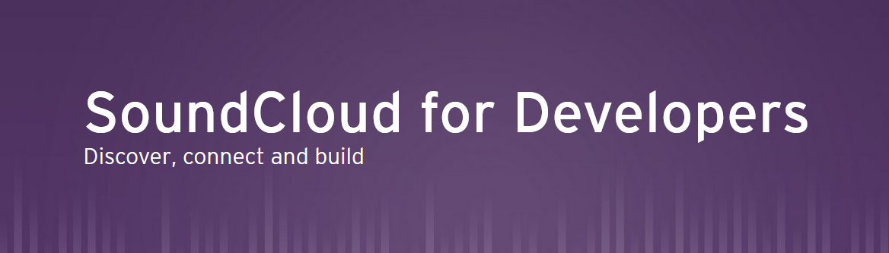

Spotify is not the only streaming monolith to give access to a public API. Soundcloud has their own extensive interface and documentation, found on <https://developers.soundcloud.com/>. It works overall in the same way as the Spotify API does but allows for many more functions to manipulate a user’s data.

It also allows for track manipulation, as long as the user has the authorization to control a track, as in – it is their tracks. Soundcloud is a much more open streaming service and gives any user the possibility to release music created by them.

Unfortunately, this API does not seem to have garnered the attention it has with Spotify – namely by developers, as no libraries have been created from it.

* 1. **Third-party APIs**

Several interfaces have also been created by freelance developers to help others in their music-related projects. Sadly, there are not many that have proven to be as efficient as Spotify and Soundcloud’s projects, at least within the time spent researching on this topic and writing this paper, or in indefinite hiatus during development. Several examples will be given for the sake of information, nevertheless.



**RateYourMusic API –** The current largest database of musical content is known as a long-running website named rateyourmusic.com. It is a site for looking up and reviewing musical projects sent from users. As it is among the many websites that are self-sustainable (have their server costs kept up only from donations from users, without sponsors or advertisements), the developers oftentimes have a close connection with its userbase and gain feedback relatively often.

With this came the idea of community tasks within rateyourmusic.com’s forum, one of which is a suggestion for an API that allows developers to tap into their database and use it for music documentation. Unfortunately, this project has been in progress since 2009 and updates have been scarce. This still felt worth mentioning in this paper, because it is possible that in the future this public API is released and will fulfil the role of documentation in the music sphere in the form of websites like IMDB and Metacritic that developers may use.

**TheAudioDB –** TheAudioDB is a community driven database of audio metadata. It is generally a self-sustained website in the same way as RYM, but in this case the database of musical data is as well.

The overall adaptability of this API has left some to be asked for. Currently, it only offers documentation for PHP and from research in its website it is not a stretch to assume it is only tested in that language. On top of that, it has very limited capabilities – with the vast majority of available controllers being only fetches, and many of the more complex fetch functions are locked behind paid subscriptions. Overall, this seems like a less favorable API to work with than the ones made by streaming services and less extensive.

**III. What can one do with these APIs?**

Several APIs have been mentioned in this paper. But the explanations do not portray the true potential that one can make with these provided interfaces. This paragraph is for displaying complete projects that use the Spotify interfaces and databases and show that the possibilities are much more than one would naturally expect.

**Stats for Spotify –** Stats for Spotify is a relatively basic but very helpful website for looking into details of your account that you can not access from any of Spotify’s official applications. It allows you to log in with your Spotify using the API’s login and token functions, then siphons the listening data of your account – most played tracks and artists on a basis of 3 months, 6 months, and all time. But this is only the main function (see fig. below). Like the rest of the projects mentioned in this paragraph, they are all third-party and separate from these streaming service corporations and it is incredibly impressive what unique applications they can apply using the data.

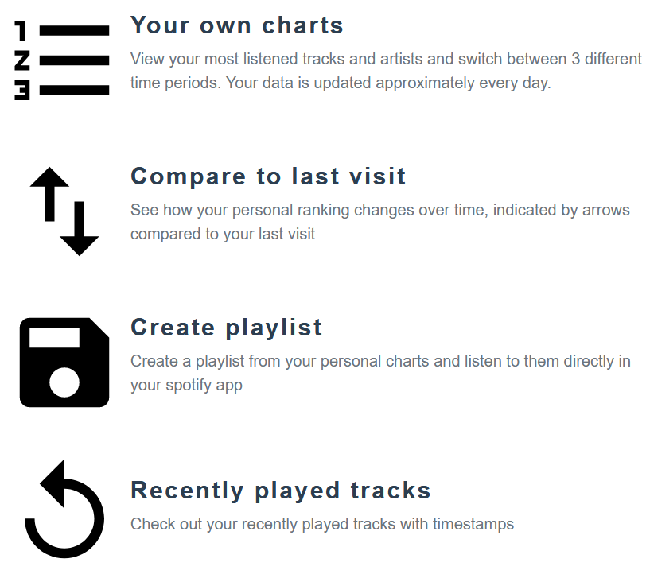

**How Bad is Your Spotify? –** This application is quite amusing and recent. Surfaced around late December 2020, How Bad is Your Spotify is a website where you can log in with your account and an AI robot goes through your listening history and habits to…tell you how awful your taste in music is while showing examples of your preferences, which most musical critics would deem to not be high quality.

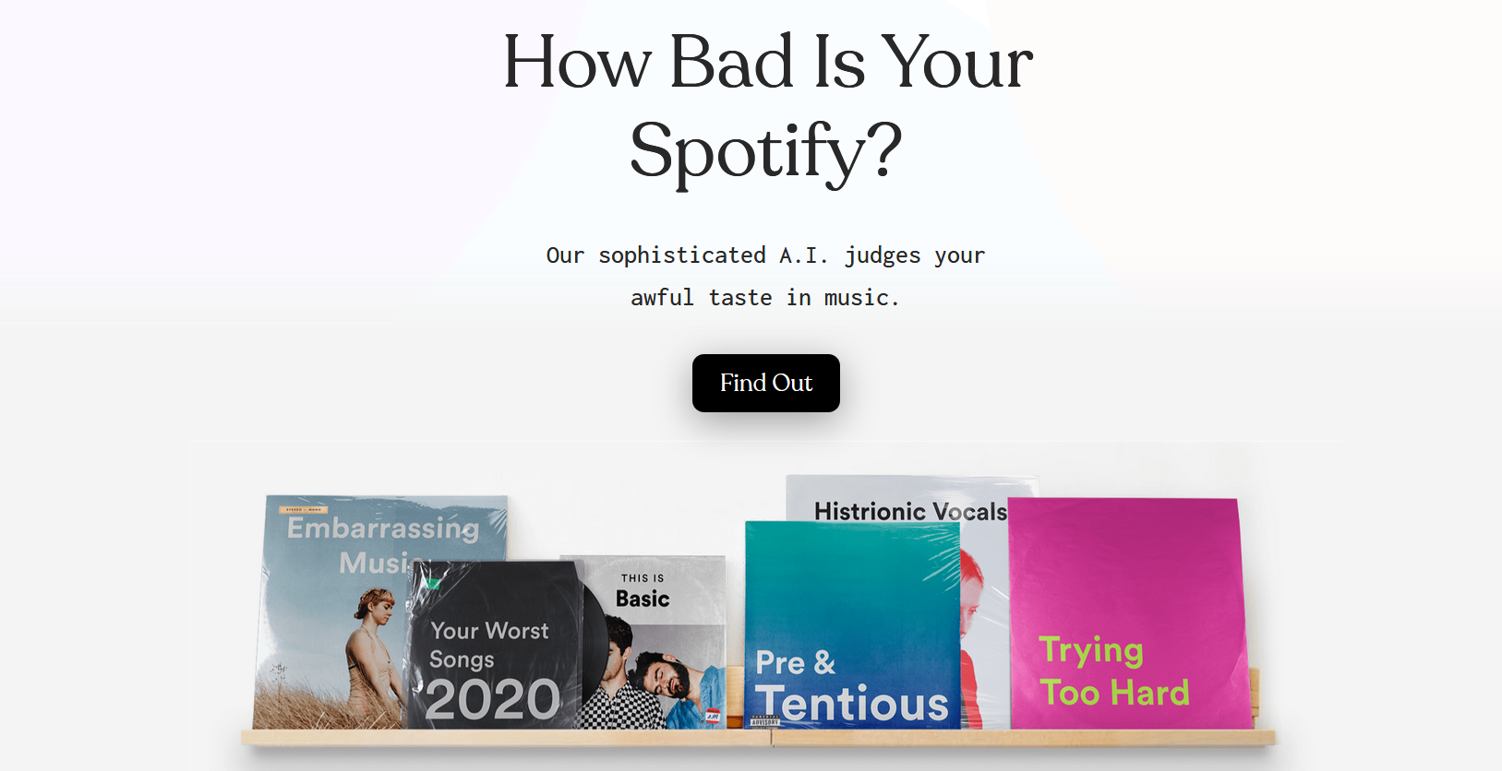

The way the A.I. works is it goes through multiple trusted music-related websites (Pitchfork, Pigeons and Planes, The Needle Drop, etc.) to gather data on each album’s score among critics. Then it checks your listening history, same as Stats for Spotify does, except unlike the previous website, here the A.I. will insult your taste while checking it in a UX resembling a messaging application.

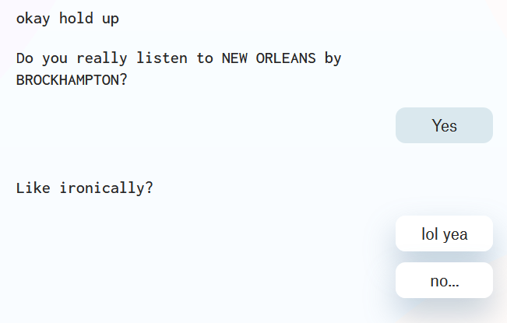

While this is, outside of entertainment purposes, a relatively useless program as it applies nothing to the average user, it must be said that this is a very impressive feat tied to an incredibly unique and humorous idea and proves that the capabilities that the provided APIs of Spotify and Soundcloud can hold.

**IV. Conclusion**

Music has become a monolith of an industry in the world wide web in less than a decade. In such little time, it has grown so large that the tools that the largest corporations use feel safe to share to the public and allow people to make their own creations. Some have created helpful applications for the curious fans of the medium, some – helped the even more curious find new music for them to enjoy, and even some made applications that make fun of people’s taste. While there are developers that have attempted to create their own interface, none could compare to the clean, extensive, and well-documented APIs of Spotify and Soundcloud. And with foundation like this, developers are sure to proceed with the same amount of creativity in the future.

Citations:

Spotify for Developers. (n.d.). Retrieved January 07, 2021, from <https://developer.spotify.com/>

SoundCloud for Developers. (n.d.). Retrieved January 07, 2021, from <https://developers.soundcloud.com/>

Welcome to TheAudioDB. (n.d.). Retrieved January 07, 2021, from <https://www.theaudiodb.com/>

RYM Webservice/API - Rate Your Music. (2009, July 7). Retrieved January 7, 2021, from <https://rateyourmusic.com/rymzilla/view?id=683>

Giuliani-Hoffman, F. (2020, December 24). This snarky bot will brutally take you down for your Spotify taste. Retrieved January 07, 2021, from <https://edition.cnn.com/2020/12/24/entertainment/spotify-ai-bot-judges-your-taste-in-music-trnd/index.html>

Stats for Spotify. (n.d.). Retrieved January 07, 2021, from <https://www.statsforspotify.com/>